**การค้นหาแบบ HILL-CLIMBING SEARCH**

ฟังก์ชันฮิวริสติกที่นิยมขึ้นในข้างดังนั้น สามารถนำมาช่วยกระบวนการค้นหาเพื่อให้ได้คำตอบ

อย่างรวดเร็วและมีประสิทธิ์ภาพ วิธีการที่จะนำฟังก์ชันฮิวริสติกมาใช้มีหลายวิธีด้วยกันขึ้นอยู่กับว่าจะใช้

ในลักษณะใด เช่นเลือกสถานะที่มีค่าฮิวริสติกดีขึ้น แล้วเดินไปยัง สถานะนั้นเลยโดยไม่ต้องสนใจสถานะ

ที่มีฮิวริสติกแย่ลง แล้วพิจารณาสถานะเหล่านี้ทีหลัง เป็นต้นในส่วนต่อไปนี้จะกล่าวถึงอัลกอริทึมต่างๆ

ที่นำฟังก์ชันฮิวริสติกมาช่วยในการค้นหาคำตอบ โดยเริ่มจากอัลกอริทึมปีนเขา

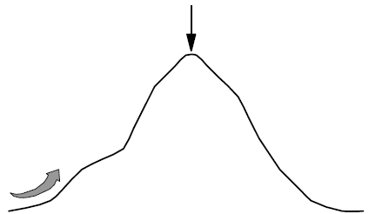

**รูป** อัลกอริทึมปีนเขา

การค้นหาแบบนี้เปรียบเสมือนการปืนไปสู่ยอดเขา ชึ่งอัลกอริทึมจะขึ้นในแนวดิ่งตลอด ถ้าเจอทางแยกเราก็จะไปแยกที่ตรงดิ่งขึ้นไปจนกระทั่งถึงยอดเขาความสูงจากฐานภูเขาจนถึงตำแหน่งที่อยู่ในปัจจุบันก็จะเปรียบเหมือนค่าฮิวริสติก ชื่งในที่นี้ยิ่งมากยิ่งดี

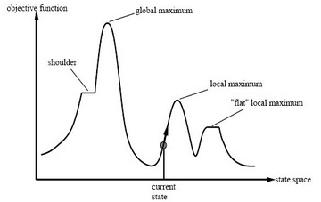

**รูป** อัลกอริทึมปีนเขา

- จะค้นหาโดยเลือกสถานะที่มีค่า Heuristic ที่ดีไปเรื่อยๆ จนกว่าจะพบสถานะเป้าหมายที่ต้องการ   
 เปรียบเสมือนกับการปีนเขา นักปีนเขาจะเลือกหาเส้นทางเดินขึ้นไปจนกว่าจะพบยอดเขาสูงสุด  
- ข้อเสียวิธีนี้ คือ ห้ามเดินย้อนกลับไปสู่สถานะก่อนหน้า และห้ามเลือกเส้นทางสถานะที่มีค่า Heuristic แย่  
 ลงกว่าเดิม

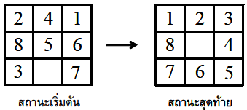

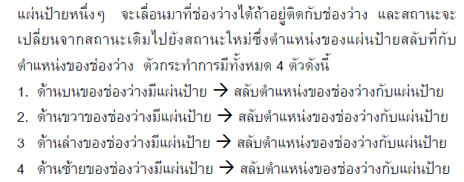

**อัลกอริทึม HILL-CLIMBING SEARCH**

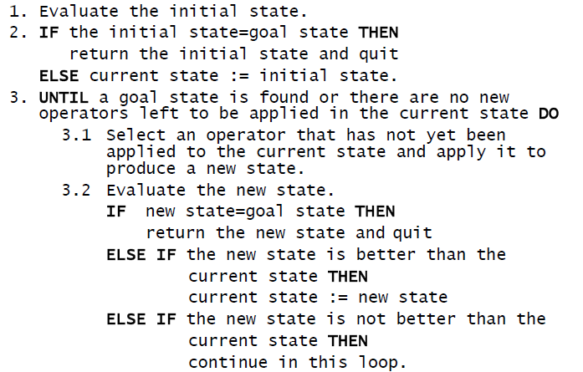

**โค้ดโปรแกรม HILL-CLIMBING SEARCH**

Public Class Form1  
Dim num As Integer  
Dim num2 As Integer  
Dim H As Integer

Private Sub Form1_Load(ByVal sender As System.Object, ByVal e As System.EventArgs) Handles MyBase.Load  
  
B10.Text = "1"  
B11.Text = "2"  
B12.Text = "3"  
B13.Text = "8"  
B14.Text = " "  
B15.Text = "4"  
B16.Text = "7"  
B17.Text = "6"  
B18.Text = "5"  
B14.BackColor = Color.White  
num = 0  
num2 = 0

End Sub  
  
Private Sub Button3_Click(ByVal sender As System.Object, ByVal e As System.EventArgs) Handles Button3.Click

B1.BackColor = Color.Red  
B2.BackColor = Color.Red  
B3.BackColor = Color.Red  
B4.BackColor = Color.Red  
B5.BackColor = Color.Red  
B6.BackColor = Color.Red  
B7.BackColor = Color.Red  
B8.BackColor = Color.Red  
B9.BackColor = Color.Red

C1.BackColor = Color.Red  
C2.BackColor = Color.Red  
C3.BackColor = Color.Red  
C4.BackColor = Color.Red  
C5.BackColor = Color.Red  
C6.BackColor = Color.Red  
C7.BackColor = Color.Red  
C8.BackColor = Color.Red  
C9.BackColor = Color.Red

If num = 0 Then  
B1.Text = "1"  
B2.Text = "2"  
B3.Text = "3"  
B4.Text = "7"  
B5.Text = "4"  
B6.Text = " "  
B7.Text = "6"  
B8.Text = "8"  
B9.Text = "5"

C1.Text = "1"  
C2.Text = "2"  
C3.Text = "3"  
C4.Text = "7"  
C5.Text = "4"  
C6.Text = " "  
C7.Text = "6"  
C8.Text = "8"  
C9.Text = "5"

H = 5  
C6.BackColor = Color.White  
B6.BackColor = Color.White  
End If  
If num = 1 Then  
B1.Text = "1"  
B2.Text = "2"  
B3.Text = " "  
B4.Text = "7"  
B5.Text = "8"  
B6.Text = "3"  
B7.Text = "6"  
B8.Text = "5"  
B9.Text = "4"

C1.Text = "1"  
C2.Text = "2"  
C3.Text = " "  
C4.Text = "7"  
C5.Text = "8"  
C6.Text = "3"  
C7.Text = "6"  
C8.Text = "5"  
C9.Text = "4"

H = 6  
B3.BackColor = Color.White  
C3.BackColor = Color.White  
End If

If num = 2 Then  
  
B1.Text = "2"  
B2.Text = "8"  
B3.Text = "3"  
B4.Text = "1"  
B5.Text = "6"  
B6.Text = "4"  
B7.Text = "7"  
B8.Text = " "  
B9.Text = "5"

C1.Text = "2"  
C2.Text = "8"  
C3.Text = "3"  
C4.Text = "1"  
C5.Text = "6"  
C6.Text = "4"  
C7.Text = "7"  
C8.Text = " "  
C9.Text = "5"

H = 5  
C8.BackColor = Color.White  
B8.BackColor = Color.White

End If  
If num = 3 Then  
B1.Text = "1"  
B2.Text = " "  
B3.Text = "3"  
B4.Text = "8"  
B5.Text = "2"  
B6.Text = "5"  
B7.Text = "7"  
B8.Text = "4"  
B9.Text = "6"

C1.Text = "1"  
C2.Text = " "  
C3.Text = "3"  
C4.Text = "8"  
C5.Text = "2"  
C6.Text = "5"  
C7.Text = "7"  
C8.Text = "4"  
C9.Text = "6"

H = 5  
C2.BackColor = Color.White  
B2.BackColor = Color.White  
End If  
If num = 4 Then  
B1.Text = "1"  
B2.Text = "3"  
B3.Text = "4"  
B4.Text = "8"  
B5.Text = "6"  
B6.Text = "2"  
B7.Text = " "  
B8.Text = "7"  
B9.Text = "5"

C1.Text = "1"  
C2.Text = "3"  
C3.Text = "4"  
C4.Text = "8"  
C5.Text = "6"  
C6.Text = "2"  
C7.Text = " "  
C8.Text = "7"  
C9.Text = "5"

H = 6  
C7.BackColor = Color.White  
B7.BackColor = Color.White  
End If

TextBox1.Text = H

If num = 4 Then  
num = -1  
End If  
num = num + 1  
num2 = 0

End Sub  
Private Sub Button4_Click(ByVal sender As System.Object, ByVal e As System.EventArgs) Handles Button4.Click

B1.BackColor = Color.Red  
B2.BackColor = Color.Red  
B3.BackColor = Color.Red  
B4.BackColor = Color.Red  
B5.BackColor = Color.Red  
B6.BackColor = Color.Red  
B7.BackColor = Color.Red  
B8.BackColor = Color.Red  
B9.BackColor = Color.Red  
num2 = num2 + 1

If num = 1 Then  
If num2 = 1 Then  
B1.Text = "1"  
B2.Text = "2"  
B3.Text = "3"  
B4.Text = "7"  
B5.Text = " "  
B6.Text = "4"  
B7.Text = "6"  
B8.Text = "8"  
B9.Text = "5"  
B5.BackColor = Color.White  
End If  
If num2 = 2 Then  
B1.Text = "1"  
B2.Text = "2"  
B3.Text = "3"  
B4.Text = "7"  
B5.Text = "8"  
B6.Text = "4"  
B7.Text = "6"  
B8.Text = " "  
B9.Text = "5"  
B8.BackColor = Color.White  
End If  
If num2 = 3 Then  
B1.Text = "1"  
B2.Text = "2"  
B3.Text = "3"  
B4.Text = "7"  
B5.Text = "8"  
B6.Text = "4"  
B7.Text = " "  
B8.Text = "6"  
B9.Text = "5"  
B7.BackColor = Color.White  
End If  
If num2 = 4 Then  
B1.Text = "1"  
B2.Text = "2"  
B3.Text = "3"  
B4.Text = " "  
B5.Text = "8"  
B6.Text = "4"  
B7.Text = "7"  
B8.Text = "6"  
B9.Text = "5"  
B4.BackColor = Color.White  
End If  
If num2 = 5 Then  
B1.Text = "1"  
B2.Text = "2"  
B3.Text = "3"  
B4.Text = "8"  
B5.Text = " "  
B6.Text = "4"  
B7.Text = "7"  
B8.Text = "6"  
B9.Text = "5"  
B5.BackColor = Color.White  
End If  
If num2 > 5 Then  
B5.BackColor = Color.White  
End If  
End If

'///////////////////////  
If num = 2 Then  
If num2 = 1 Then  
B1.Text = "1"  
B2.Text = "2"  
B3.Text = "3"  
B4.Text = "7"  
B5.Text = "8"  
B6.Text = " "  
B7.Text = "6"  
B8.Text = "5"  
B9.Text = "4"  
B6.BackColor = Color.White  
End If  
If num2 = 2 Then  
B1.Text = "1"  
B2.Text = "2"  
B3.Text = "3"  
B4.Text = "7"  
B5.Text = "8"  
B6.Text = "4"  
B7.Text = "6"  
B8.Text = "5"  
B9.Text = " "  
B9.BackColor = Color.White  
End If  
If num2 = 3 Then  
B1.Text = "1"  
B2.Text = "2"  
B3.Text = "3"  
B4.Text = "7"  
B5.Text = "8"  
B6.Text = "4"  
B7.Text = "6"  
B8.Text = " "  
B9.Text = "5"  
B8.BackColor = Color.White  
End If  
If num2 = 4 Then  
B1.Text = "1"  
B2.Text = "2"  
B3.Text = "3"  
B4.Text = "7"  
B5.Text = "8"  
B6.Text = "4"  
B7.Text = " "  
B8.Text = "6"  
B9.Text = "5"  
B7.BackColor = Color.White  
End If  
If num2 = 5 Then  
B1.Text = "1"  
B2.Text = "2"  
B3.Text = "3"  
B4.Text = " "  
B5.Text = "8"  
B6.Text = "4"  
B7.Text = "7"  
B8.Text = "6"  
B9.Text = "5"  
B4.BackColor = Color.White  
End If  
If num2 = 6 Then  
B1.Text = "1"  
B2.Text = "2"  
B3.Text = "3"  
B4.Text = "8"  
B5.Text = " "  
B6.Text = "4"  
B7.Text = "7"  
B8.Text = "6"  
B9.Text = "5"  
B5.BackColor = Color.White  
End If  
If num2 > 6 Then  
B5.BackColor = Color.White  
End If  
End If

'////////////////////////////////////////////  
If num = 3 Then  
If num2 = 1 Then  
B1.Text = "2"  
B2.Text = "8"  
B3.Text = "3"  
B4.Text = "1"  
B5.Text = " "  
B6.Text = "4"  
B7.Text = "7"  
B8.Text = "6"  
B9.Text = "5"  
B5.BackColor = Color.White  
End If  
If num2 = 2 Then  
B1.Text = "2"  
B2.Text = " "  
B3.Text = "3"  
B4.Text = "1"  
B5.Text = "8"  
B6.Text = "4"  
B7.Text = "7"  
B8.Text = "6"  
B9.Text = "5"  
B2.BackColor = Color.White  
End If  
If num2 = 3 Then  
B1.Text = " "  
B2.Text = "2"  
B3.Text = "3"  
B4.Text = "1"  
B5.Text = "8"  
B6.Text = "4"  
B7.Text = "7"  
B8.Text = "6"  
B9.Text = "5"  
B1.BackColor = Color.White  
End If  
If num2 = 4 Then  
B1.Text = "1"  
B2.Text = "2"  
B3.Text = "3"  
B4.Text = " "  
B5.Text = "8"  
B6.Text = "4"  
B7.Text = "7"  
B8.Text = "6"  
B9.Text = "5"  
B4.BackColor = Color.White  
End If  
If num2 = 5 Then  
B1.Text = "1"  
B2.Text = "2"  
B3.Text = "3"  
B4.Text = "8"  
B5.Text = " "  
B6.Text = "4"  
B7.Text = "7"  
B8.Text = "6"  
B9.Text = "5"  
B5.BackColor = Color.White  
End If  
If num2 > 5 Then  
B5.BackColor = Color.White  
End If  
End If

'///////////////////////////////////////////////////////

If num = 4 Then  
If num2 = 1 Then  
B1.Text = "1"  
B2.Text = "2"  
B3.Text = "3"  
B4.Text = "8"  
B5.Text = " "  
B6.Text = "5"  
B7.Text = "7"  
B8.Text = "4"  
B9.Text = "6"  
B5.BackColor = Color.White  
End If  
If num2 = 2 Then  
B1.Text = "1"  
B2.Text = "2"  
B3.Text = "3"  
B4.Text = "8"  
B5.Text = "4"  
B6.Text = "5"  
B7.Text = "7"  
B8.Text = " "  
B9.Text = "6"  
B8.BackColor = Color.White  
End If  
If num2 = 3 Then  
B1.Text = "1"  
B2.Text = "2"  
B3.Text = "3"  
B4.Text = "8"  
B5.Text = "4"  
B6.Text = "5"  
B7.Text = "7"  
B8.Text = "6"  
B9.Text = " "  
B9.BackColor = Color.White  
End If  
If num2 = 4 Then  
B1.Text = "1"  
B2.Text = "2"  
B3.Text = "3"  
B4.Text = "8"  
B5.Text = "4"  
B6.Text = " "  
B7.Text = "7"  
B8.Text = "6"  
B9.Text = "5"  
B6.BackColor = Color.White  
End If  
If num2 = 5 Then  
B1.Text = "1"  
B2.Text = "2"  
B3.Text = "3"  
B4.Text = "8"  
B5.Text = " "  
B6.Text = "4"  
B7.Text = "7"  
B8.Text = "6"  
B9.Text = "5"  
B5.BackColor = Color.White  
End If  
If num2 > 5 Then  
B5.BackColor = Color.White  
End If  
End If

'/////////////////////////////////////////////////////////////  
If num = 0 Then  
If num2 = 1 Then  
B1.Text = "1"  
B2.Text = "3"  
B3.Text = "4"  
B4.Text = "8"  
B5.Text = "6"  
B6.Text = "2"  
B7.Text = "7"  
B8.Text = " "  
B9.Text = "5"  
B8.BackColor = Color.White  
End If  
If num2 = 2 Then  
B1.Text = "1"  
B2.Text = "3"  
B3.Text = "4"  
B4.Text = "8"  
B5.Text = " "  
B6.Text = "2"  
B7.Text = "7"  
B8.Text = "6"  
B9.Text = "5"  
B5.BackColor = Color.White  
End If  
If num2 = 3 Then  
B1.Text = "1"  
B2.Text = "3"  
B3.Text = "4"  
B4.Text = "8"  
B5.Text = "2"  
B6.Text = " "  
B7.Text = "7"  
B8.Text = "6"  
B9.Text = "5"  
B6.BackColor = Color.White  
End If  
If num2 = 4 Then  
B1.Text = "1"  
B2.Text = "3"  
B3.Text = " "  
B4.Text = "8"  
B5.Text = "2"  
B6.Text = "4"  
B7.Text = "7"  
B8.Text = "6"  
B9.Text = "5"  
B3.BackColor = Color.White  
End If  
If num2 = 5 Then  
B1.Text = "1"  
B2.Text = " "  
B3.Text = "3"  
B4.Text = "8"  
B5.Text = "2"  
B6.Text = "4"  
B7.Text = "7"  
B8.Text = "6"  
B9.Text = "5"  
B2.BackColor = Color.White  
End If  
If num2 = 6 Then  
B1.Text = "1"  
B2.Text = "2"  
B3.Text = "3"  
B4.Text = "8"  
B5.Text = " "  
B6.Text = "4"  
B7.Text = "7"  
B8.Text = "6"  
B9.Text = "5"  
B5.BackColor = Color.White  
End If

If num2 > 6 Then  
B5.BackColor = Color.White  
End If

End If  
If H <> 0 Then  
H = H - 1  
End If

TextBox1.Text = H

End Sub

End Class

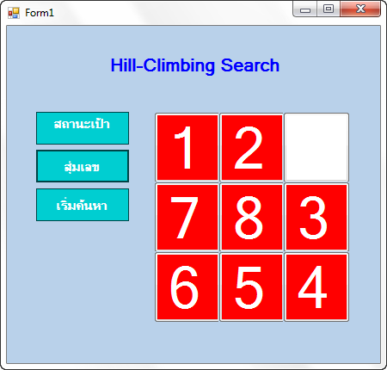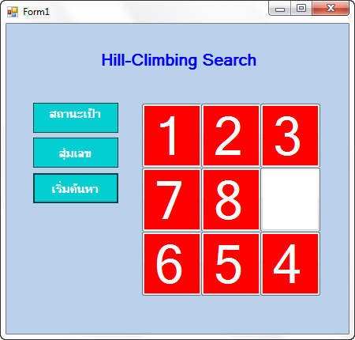ผลการรันโปรแกรม

